

Group Integrity Statement

In submitting this work we confirm that it is entirely our own work. We
acknowledge that we may be invited to online interview if there is any concern in
relation to the integrity of my submission, and we are aware that any breach will
be subject to the University's Procedures for dealing with breaches of Exam
Regulations. We are aware of what the University of Galway plagiarism policy
entails.

In accordance with the University’s Academic Integrity policy QA220, we confirm the following (please tick each statement):
We understand the consequences of submitting work that does not adhere to the University’s Academic Integrity policy QA220 with respect to plagiarism (intentional or unintentional) | 
The work we are submitting is our own for assessment has not been produced, commercially or otherwise, by a third party for a pre-agreed fee (contracted)
The work we are submitting has not been done in whole or in part completed by someone else nor has it been created artificially, e.g., by a machine or through artificial intelligence such as ChatGPT
All materials used in the work has been referenced appropriately, are genuine and authentic to the claims made (i.e., it references have not been falsified to give credibility to the assignment)
We confirm that we have not taken part in collusion (students working together unless it is a group project); or used ‘essay mills’ to carry out the allocated part of the project

Submitted by:

Name | Student ID
Amit Kumar | 24236930
Akshata Ghumatkar | 24240627
Bhaviya Sree | 24237748
Jeffrey Ifeagwu | 21317183
Aniruddha Girish Jamakhandi | 24242000
Ramya Chodumada Nanjappa | 24241850

Data Overview

Dataset 1- IBM Employee Attrition & Performance
The dataset used for this analysis is the HR Employee Attrition Dataset, which provides detailed information about employees within an organization, including their demographics, job-related factors, and attrition status. The dataset contains a mix of categorical and continuous variables, making it suitable for applying advanced statistical techniques.
Dataset Features:
- Number of Observations: 1,470 employees
- Number of Variables: 35 columns, including:
  - Employee Demographics: Age, Gender, Marital Status, etc.
  - Job-Related Variables: Job Role, Job Satisfaction, Department, Work-Life Balance, Monthly Income, etc.
  - Performance Metrics: Performance Rating, OverTime, Years at Company, etc.
  - Attrition (Yes/No): indicating whether an employee has left the organization.
Data Types:
- Categorical Variables: Attrition, Job Role, Department, Gender, etc.
- Continuous Variables: Age, Income, Years at Company, Total Working Hours, etc.

Dataset 2 - Athelete Performance
This dataset consists of performance measurements collected from 12 participants categorized as Trained or Untrained athletes. Each participant’s performance was evaluated under four conditions that combine stretching and warm-up routines:
- No Stretch + No Warm-Up
- No Stretch + Warm-Up
- Stretch + No Warm-Up
- Stretch + Warm-Up
The goal of this dataset is to investigate the individual and combined effects of stretching and warm-up routines on athletic performance and to determine whether these effects differ based on training status (Trained vs. Untrained). This design allows for exploring both between-subjects factors (Training Status) and within-subjects factors (Stretching and Warm-Up Conditions), making it ideal for Mixed Model ANOVA analysis.

Data Preprocessing
To ensure the dataset was suitable for analysis, the following preprocessing steps were performed:
- No missing values were found in the dataset.
- No outliers were identified; all values were deemed significant.
- Categorical variables were encoded into numerical formats.
- Continuous variables were standardized when required.

Q1. Logistic Regression

Objective and Methodology
“Can DistanceFromHome, WorkLifeBalance, and JobSatisfaction predict whether an employee is likely to leave the organization, and does the effect of DistanceFromHome depend on WorkLifeBalance ?”
The Logistic regression is used to determine whether DistanceFromHome, WorkLifeBalance, and JobSatisfaction can predict whether an employee is likely to leave the organization and whether the effect of DistanceFromHome depends on WorkLifeBalance (interaction effect).

Results and Interpretation
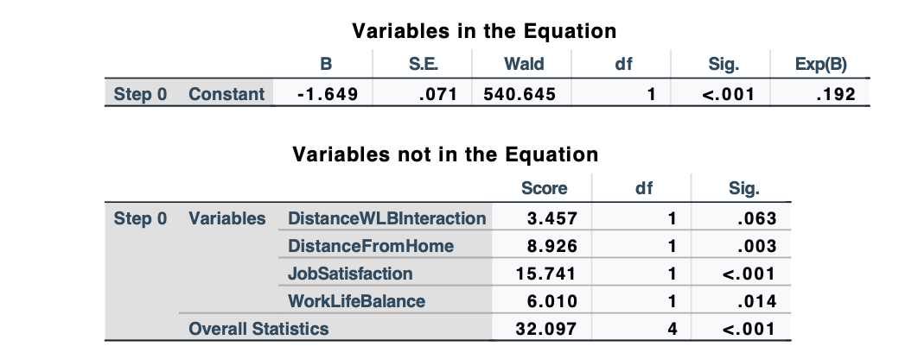
The first output (Step 0) provides insights into the baseline model before any predictors were included. The constant (B=−1.649) indicates the baseline log-odds of attrition, and the odds ratio (Exp(B)=0.192) reflects a low likelihood of employees leaving when no predictors are added. Among the variables considered, JobSatisfaction is the strongest predictor (with p<0.001), meaning higher satisfaction significantly reduces the likelihood of attrition. DistanceFromHome (p=0.003) and WorkLifeBalance (p=0.014) also show significant effects on attrition. But the interaction between DistanceFromHome and WorkLifeBalance is not significant (with p=0.063).
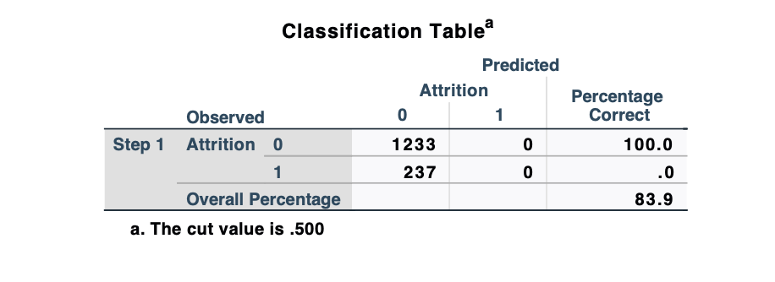
The second output, the Classification Table, shows model's ability to predict attrition. The model accurately classifies all non-attrition cases (1,233 employees staying), achieving a 100% success rate for this group. However, it fails to predict any attrition cases, misclassifying all 237 employees who left as non-attrition. This imbalance indicates that the model is biased toward predicting employees staying, likely due to an uneven distribution of attrition and non-attrition cases in the dataset. The overall accuracy of 83.9% is misleading, as it primarily reflects the model's performance in predicting non-attrition cases.
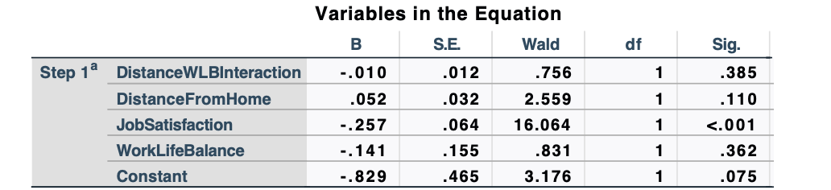
The third output (Step 1) shows the impact of the predictors after being included in the model. JobSatisfaction (B=−0.257,p<0.001) remains the most significant predictor, with a one-unit increase reducing the odds of attrition by 23% (Exp(B)=0.774). DistanceFromHome (B=0.052,p=0.110) and WorkLifeBalance (B=−0.141,p=0.362) are not significant predictors, meaning their effects on attrition are weak and statistically insignificant. The interaction between DistanceFromHome and WorkLifeBalance (B=−0.010,p=0.385) is also not significant, indicating no meaningful combined effect on attrition. The constant (B=−0.829,p=0.075) reflects the baseline log-odds of attrition when all predictors are zero.
In summary, JobSatisfaction is the only significant factor affecting attrition, with higher satisfaction strongly reducing the likelihood of leaving. Neither DistanceFromHome nor WorkLifeBalance significantly influences attrition on their own or through interaction.

Q2. Kruskal Wallis Test

Objective and Methodology
“Does the number of years an employee has worked at the company (YearsAtCompany) and their standard working hours (StandardHours) have a significant effect on promotions (YearsSinceLastPromotion)?”

A Kruskal-Wallis test was applied to examine whether the distributions of YearsAtCompany and StandardHours vary across categories of YearsSinceLastPromotion. This non-parametric test is suitable for comparing groups when the assumptions of normality or homogeneity of variances are violated. The independent variable is YearsSinceLastPromotion, while the dependent variables are YearsAtCompany and StandardHours.

Results and Interpretation
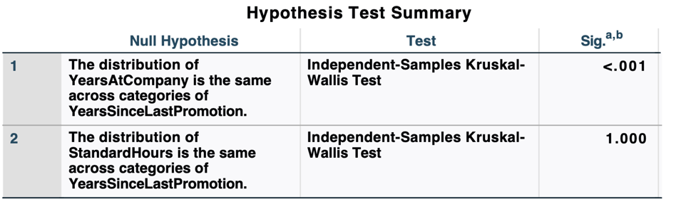
The Kruskal-Wallis test results indicate that the distribution of YearsAtCompany varies significantly across categories of YearsSinceLastPromotion (p<0.001p<0.001). This suggests that employees with different lengths of time since their last promotion tend to have differing tenures at the company. In contrast, the distribution of StandardHours remains consistent across these categories (p=1.000p=1.000), showing that standard working hours have no relationship with promotion timing, likely because all employees have uniform working hours.
The pairwise comparisons reveal significant differences in YearsAtCompany between many categories of YearsSinceLastPromotion (p<0.05p<0.05). Employees with shorter intervals since their last promotion (e.g., 0 years) have significantly different tenures compared to those with longer intervals (e.g., 5+ years), highlighting tenure as a key factor in promotion timing.

Q3. Mixed Model ANOVA Report

Objective and Methodology
“How do different combinations of stretching and warm-up routines influence athletic performance, and does this effect differ between Trained and Untrained athletes?”
DataSet: Athelete performance dataset.
A Mixed Model ANOVA was carried out to investigate the effect of different stretching and warm-up routines on athletic performance across four conditions: No Stretch + No Warm-Up, No Stretch + Warm-Up, Stretch + No Warm-Up, Stretch + Warm-Up
Furthermore, the analysis examined whether these effects differed based on Athlete Type (Trained vs. Untrained).
Hypotheses
- Within-Subjects Main Effect (Condition):Null Hypothesis (H0​): There is no significant difference in performance across the four conditions. Alternative Hypothesis (H1​): There is a significant difference in performance across the four conditions.
- Between-Subjects Main Effect (Athlete Type):Null Hypothesis (H0​): There is no significant difference in performance between Trained and Untrained athletes. Alternative Hypothesis (H1​): There is a significant difference in performance between Trained and Untrained athletes.
- Interaction Effect (Condition × Athlete Type):Null Hypothesis (H0): The effect of condition on athletes’ performances do not differ based on athlete type. Alternative Hypothesis (H1): The effect of condition on athletes’ performances do differ based on athlete type.

Results and Interpretation
Main Effect of Condition
The analysis shows a significant main effect of condition, F(3,30) = 84.645, p < 0.001, with quite a large effect size (Partial Eta Squared = 0.894). This suggests that performance significantly varied across the four conditions.
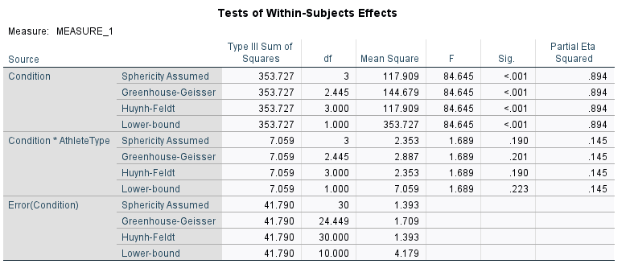

The profile plot demonstrates that performance increases progressively across conditions, with the highest performance observed under the Stretch + Warm-Up condition.
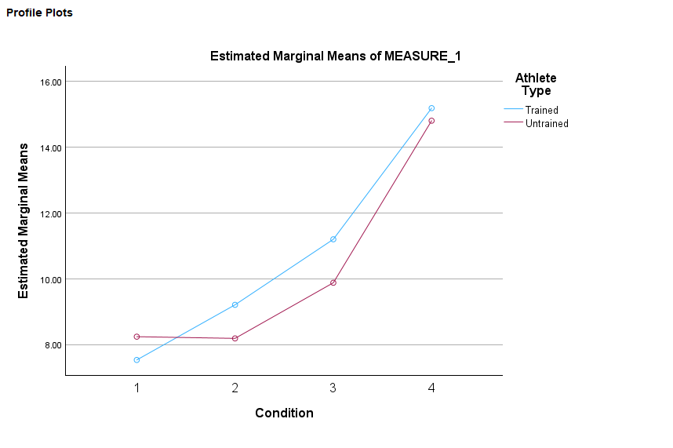

Main Effect of Athlete Type
The between-subjects main effect of athlete type was not significant, F(1,10) = 0.306, p = 0.592, Partial Eta Squared = 0.030. This indicates that there was no significant difference in overall performance between Trained and Untrained athletes.
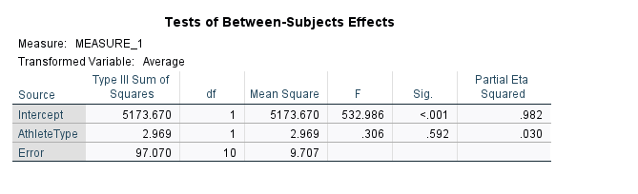
Interaction Effect (Condition × Athlete Type)
The interaction between condition and athlete type was not significant, F(3,30) = 1.689, p = 0.190, Partial Eta Squared = 0.145. This suggests that the effect of condition on performance was similar for both Trained and Untrained athletes.
The significant main effect of condition showcases the importance and the positive impact of stretching and warm-up routines on performance. This finding supports the hypothesis (H1) that performance improves with both stretching and warm-up, especially under the Stretch + Warm-Up condition.
The lack of a significant main effect of athlete type suggests that trained and untrained athletes performed similarly across conditions, which is expected given the importance of stretching and warming-up.
The non-significant interaction effect indicates that the benefits of stretching, and warm-up routines are consistent regardless of athlete type.

Assumptions
Performance measures recorded in this analysis are assumed to represent relative outcomes under each condition.
The variances of the differences between all pairs of conditions are assumed to be equal. Mauchly’s Test was used to assess this assumption, and corrections (e.g., Greenhouse-Geisser) were applied if it was violated.
The variances of performance scores across the levels of the between-subjects factor (Athlete Type: Trained vs. Untrained) are assumed to be equal. Levene’s Test was used to assess this assumption.

Q4. One-way ANCOVA

Objective and Methodology
“How do education influence employee’s work life balance after controlling job level and job satisfaction?”
- Dependent Variable: WorkLifeBalance (measured on a scale of 1 to 4).
- Fixed Factor: Education (five levels: 1, 2, 3, 4, and 5).
- Covariates: JobSatisfaction, JobLevel.
The one-way ANCOVA is performed to evaluate how education affects work-life balance. As part of the analysis, the assumptions, like the normal distribution of residuals and the consistency of variances, held true using various diagnostic tests.
Checking Assumptions
- Normality of Residuals:
- When looking at the histograms and Q-Q plots for WorkLifeBalance by Education levels, we can see that they don't quite follow a normal pattern.
- The Shapiro-Wilk test shows results (p < 0.001 for all levels) that point to clear differences from normality.
- Homogeneity of Variances:
- Levene’s Test results are F = 1.568, p = 0.180.
- This means we can say that the assumption of equal variances holds true (p > 0.05)

Results and Interpretation
H0: The average WorkLifeBalance is equal for all Education levels.
H1: The average WorkLifeBalance differs for at least one Education level when compared to the others.
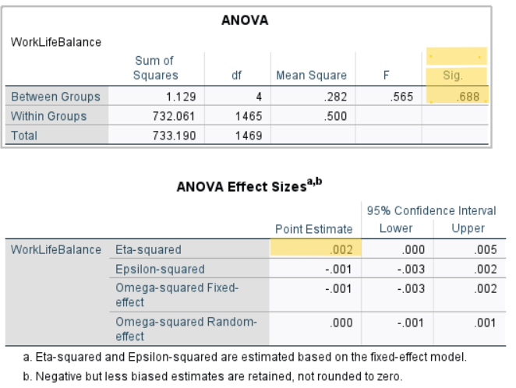
- The test is insignificant as the p value, but we do not know which Education level has insignificant WorkLifeBalance.
- The Eta-Squared shows that there is a small effect, accounting for 0.2% of the variance in WorkLifeBalance among all education levels.
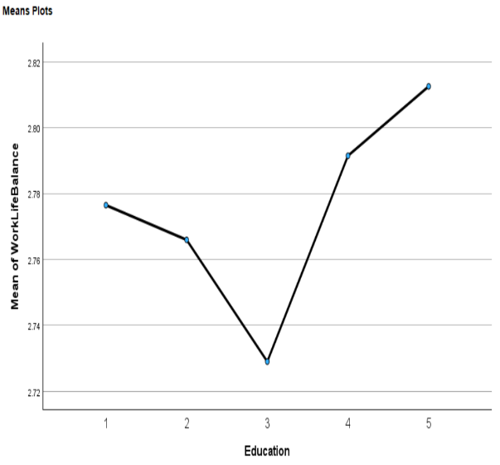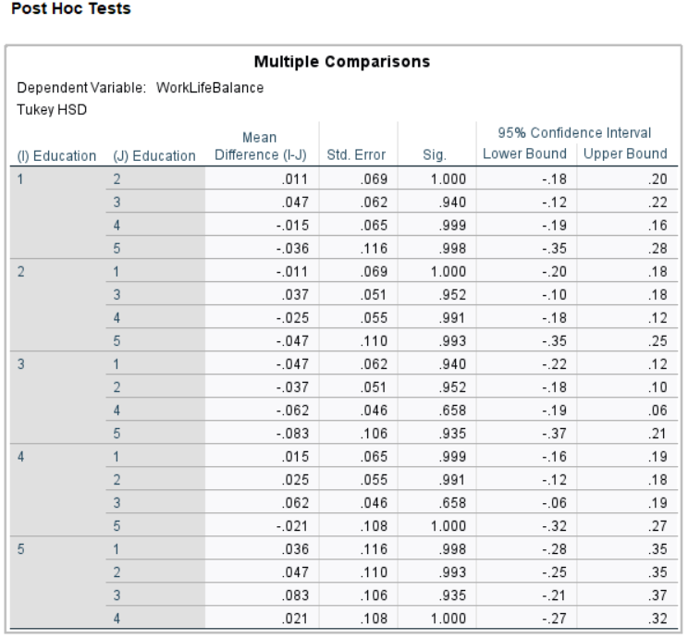
There is no significant mean difference across the different education levels since none of the mean differences are marked with asterisks.

Possible Bias -
How education impacts work-life balance may change based on what level a person is in their job and how satisfied they feel with it.

Does this link between education and work-life balance shift depending on someone's job level and their job satisfaction?

Key Idea - The values of the related factor must stay the same across different levels of the main variable, and this has been checked using an ANOVA test. 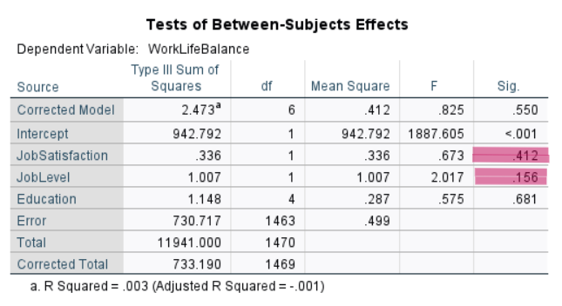 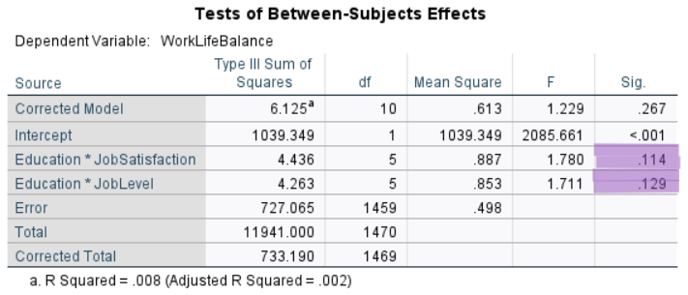

The analysis shows that, in this dataset, Education doesn't play a big role in affecting WorkLifeBalance. Although there are slight differences in average WorkLifeBalance scores based on Education levels, these differences aren’t strong enough to be considered significant. The small effect size (η² = 0.003) indicates that Education has very little real impact on WorkLifeBalance.

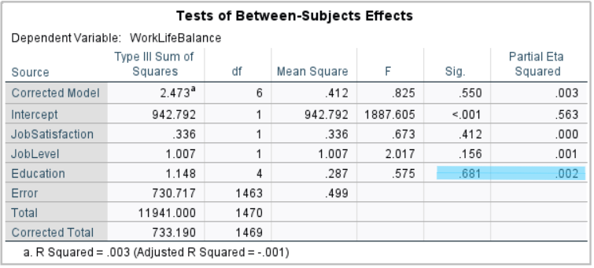

The Shapiro-Wilk test revealed that the assumption of normality was not met. Although ANCOVA can handle some small violations of this assumption, larger issues may have influenced how reliable the results are. On the positive side, the variances were consistent, which supports the model’s validity in this regard.

Reference
- University of Galway, 2024. MS5105 – Statistical Techniques for Business Analytic, modules. Galway: J.E. Cairnes School of Business & Economics. Prepared by Dr. Mona Isazad Mashinchi.
- Pavan Subhash, 2019. IBM HR Analytics Attrition Dataset. Kaggle. Available at: https://www.kaggle.com/datasets/pavansubhasht/ibm-hr-analytics-attrition-dataset/data

